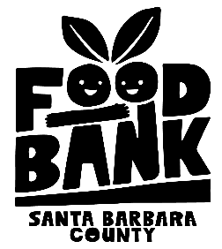
Foodbank of Santa Barbara County

JOB TITLE: Development Intern
Reports to: Development Team
Location: Santa Barbara Downtown Office

JOB FUNCTION: The Development Intern will assist the Foodbank’s Development Team in various functions, including event preparation and execution, community outreach, and donor research. This is an opportunity to learn about one of the most essential areas of nonprofit work – fund development.

PRINCIPLE DUTIES AND RESPONSIBILITIES

- Participating in the organization of, and running of, large and small fundraising events.
- Representing the Foodbank at tabling events.
- Conducting internet searches to verify information about prospective donors.
- Communicating with corporate participants in our fall Corporate Challenge by tracking volunteer hours and contributions.
- Doing other administrative activities related to fund development.

EDUCATION AND EXPERIENCE
- Currently enrolled in undergraduate degree program.
- Interest or experience in fundraising, marketing, and event planning.

SKILLS AND ABILITIES
- A commitment to the mission of the Foodbank and to modeling health and wellness.
- Strong communication, planning and organizational skills.
- Attention to detail.

