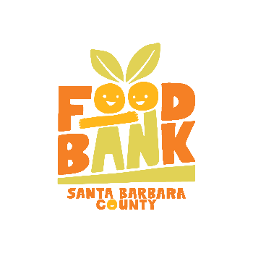
DONATION OF SECURITIES FORM
Foodbank of Santa Barbara County

Thank you for your gift of securities to Foodbank of Santa Barbara County.
Please fill out the information below.

Name & Type of Securities (e.g. IBM common stock) Number of Shares Transfer Date

Donor’s Name/DTC Memo Check if anonymous Broker’s Name

Donor’s Street Address Broker’s Company

Donor’s City/State/Zip Broker’s Phone Number

Donor’s Phone (This is critical if a question arises or a problem occurs in the donation process)
Foodbank’s broker contact information is:

The Murray Group of Morgan Stanley
c/o Aimee Harrell
(805) 928-4311
DTC# 015
Acct# 223-027193-039
Aimee.Harrell@morganstanley.com

OR...for electronic funds transfers, our Depository is Union Bank: Routing # 122000496 – Account # 0006569149
Foodbank of Santa Barbara County’s tax identification number (FEIN) is: 77-0169214
After Foodbank of Santa Barbara County receives this form and our broker confirms the donation of securities, the fund development staff will issue an official acknowledgement letter to the donor. This letter will indicate the number and type of shares received and date the stock was converted into a gift (day when record ownership of stock was transferred to Foodbank of Santa Barbara County or the stock unconditionally delivered to Foodbank of Santa Barbara County.
All contributions are tax-deductible to the fullest extent provided by law. Every effort will be made to sell non-marketable securities as quickly as possible.
Please contact Carrie Wanek at Foodbank of Santa Barbara County (805) 967-5741 x. 113 or cwanek@foodbanksbc.org when complete.

